Impact Force Location and Intensity Identification Using Joint-Position Sensors in Humanoids

Samia Choueiri
Department of Mechatronics Engineering
American University of Science and Technology
Beirut, Lebanon
samia.choueiri@hotmail.com
Hassan Diab
Department of Mechatronics Engineering
American University of Science and Technology
Beirut, Lebanon
hdiab@aust.edu.lb
Michel Owayjan
Department of Mechatronics Engineering
American University of Science and Technology
Beirut, Lebanon
mowayjan@aust.edu.lb
Roger Achkar
Department of Computer and Communications Engineering
American University of Science and Technology
Beirut, Lebanon
rachkar@aust.edu.lb

Abstract—Humanoid robots are capable of imitating humans, adapting to changes in an environment, making decisions, and performing tasks. But they are also at a high risk of being hit by an external impact force or disturbance. However, unlike humans, robots do not have sensory neurons to be able to sense the location at which they were hit as well as the intensity of the impact force. In this paper, humanoids are tested for the ability to perceive their surrounding better by recognizing the impact force location and intensity after monitoring the response of the encoders at the different joints due to an external disturbance where additional sensors to the robot are not needed. Using machine learning, several models are trained and then tested to ameliorate and increase the robustness of the stability control algorithm as it can help the robot regain stability in a more educated system. Giving the humanoid the ability to perceive its surroundings better also gives it the ability to react and control its movement and posture with a better and faster response despite the increasing number of degrees of freedom which makes controlling the robot more difficult.
Keywords— Humanoid Stabilization, Force Detection, Force Localization, Ensemble Learning.

Introduction
For many years, humans have been trying to artificially redesign the multipart and composite mechanism that constitutes it. The mission is extremely dense, but lead to the design of a machine that looks like a human, behaved and adapts to the environment in a way similar to that of humans. However, the current status of these designed robots, is not yet adequate and they are still far from autonomous and self-regulating as expected and desired. Yet, they are used in a diversity of fields. They have been used in the medical field for clinical support, in the educational field as instructors, in the industrial field to perform many tasks instead of humans, in the military field for search and rescue tasks or even combat and many other purposes in numerous fields [1].
A human like structured autonomous robot that is capable of adapting to changes in an environment, takes decisions and performs tasks is called a humanoid robot. This kind of robots is currently under-study and research as scientists and engineers aim to let this robot imitate humans in the way they move, perceive events and also make decisions. They are designed to imitate the human body and its activity when humans have a large number of degrees of freedom and yet can control their movement well even if they were subject to a sudden impact force.
The increased number of degrees of freedom in a Humanoid robot must make it even more difficult to control the movement alone. The case is even taken to a higher level of difficulty if the humanoid is subjected to an external impact force which yields to a loss in stability. Since a humanoid robot is expected and required to behave in a way imitating that of humans’, the robot should be equipped with a design including the minimal requirement for a sense of awareness or consciousness a human has. The ability of a robot to be able to know more about the external effects on it should be improved remarkably special when it comes to external effects that lead to a loss in stability.

Literature Review

Atlas
The world’s most dynamic humanoid robot is Atlas by Boston Dynamics shown in Fig. 1. It is in its examination stage, intended to stretch the boundaries of full-body mobility. The parts of its skeleton are 3D printed aircraft-grade aluminum and titanium. It is made of two arms, two legs, a head and two hands which were designed by two different contractors; one by Sandia National Labs and the other by iRobot. When assembled, the humanoid is 1.5 m high and weighs 80 kg. The robot has an on-board real-time computer. Atlas’s high level control enables the robot to demonstrate human-level agility when it comes to its power and balancing. It is made of the world’s most compact hydraulic system. The robot’s mobility impressive due to the high power delivered to all 28 hydraulic joints. The motors, valves and the hydraulic power unit are assembled and configured to ensure that a high power is delivered to the joints of the humanoid. This incredibly dynamic robot is controlled by an advanced control system leading the system to perceive its environment via LIDAR and stereo vision technology, plan and move accordingly with a speed on 1.5 m/s. Atlas was disclosed on July 11 2013 by the Defense Advanced Research Projects Agency (DARPA) to help in emergency situations being able to be operated in dangerous areas [2].
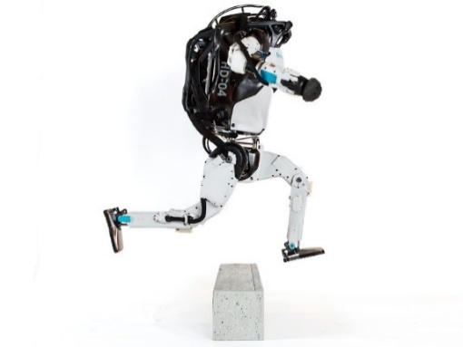
- Atlas Humanoid Robot from Boston Dynamics

State of the Art
In the paper “Multifaceted Humanoid for Surveillance & Monitoring”, Ashwin Dhande wrote about a humanoid that was designed to be sent in harsh environments for surveillance and monitoring. So, it had to be given the ability to sense a diversity of external parameters such as temperature, pressure, pH, strain, humidity and much more. Therefore, the robot had to have paper-based artificial skin, and this is to give the robot features for the robot to be able to replace humans in space [3].

Mehdi Benallegue conducted research entitled “Model-Based External Force/Moment Estimation for Humanoid Robots with No Torque Measurement” in they avoided the use of force sensors that are usually placed on the feet and the wrists since they cost a lot. The dynamics of any robot, especially humanoids, cannot be calculated unless the forces acting on the robot are declared. Usually this happens through data acquired through force and torque sensors whereas this paper estimation of the external force and the moments using an inertial mass unit on the robot [4][5].

In the “Sensorless External Force Detection Method for Humanoid Robot Arm based on BP Neural Network”, Guoyu et al increase the intelligence of the robot arm, turned the robot’s responses into more educated ones and increased its safety by detecting external forces without the use of joint torque sensors which can detect the external force of the joint space in real time during the operation of the robot. Instead of detecting the force using sensors this will be achieved through the calculation of the external torques by using the rotational position and speed of the motors in a linear dynamic model that excludes all dissipative factors from the equations. Using a deep learning algorithm, the non-linearity of the model will be compensated to reduce the error [6].

In the research “Force localized interaction sensing system for HYDROïD humanoid robot”, M. Tahoun et al. presented a new type of low-cost force localized sensor. It is dependent on mechanical deformation and mathematical models. This research is concerned with the localization of the force by distributing a set of force sensors and fixing them a distance away from each other and relating them in a mathematical model in a 2-dimensional plane [7].

Dynamic Model
The dynamic model is a mathematical model relates the motion of all joints of a humanoid robot irrespective of the high number of degrees of freedom it might have which are attached to actuator that demand control. These parameters include the position and the velocity of each joint which are results of the dynamic model. In this research, the aim is to find a relation between the variations in the position of each joint and the force at each joint due to an external disturbance. The force at the joints, when specified, is an essential input to the controller and will enhance the stability of the robot as it is giving the ability to localize and evaluate force with the help of artificial intelligence [8].

Kinematics and Dynamics
Kinematics, in common, is the study of the position, speed and increasing speed of a mechanical system without considering either the forces (or torques) that create the movement or the dynamic properties, such as mass or inertia, of the bodies. The joint space of a robot with n DoF is the n-dimensional manifold Q containing all the possible values that the joint variables q can take. Dynamics is the study of the relativity between the robot motion and the generalized forces that act on the robot generating that motion. This relation considers factors such as shapes, masses and inertia of the elements composing the robot. In the dynamic model, the motion is signified through joint variables acceleration $\ddot{q}$ , or operational points acceleration $\ddot{x}$. If the joints are revolute joints, the generalized forces are equivalent to the joint torques, and if the joints are prismatic joints they are the joint forces [8].

Newton-Euler and Lagrange-Euler
Two main approaches to computing a humanoid’s dynamic model; the Newton-Euler method and the Lagrange-Euler Method. The equations (1) of Newton are essential when it comes to solving a dynamic model of robots or mechanical system. The equation relates the acceleration under the effect of the summation of forces which is Newton’s second law of motion.
$$\sum_{i=1}^{N}{\left(dF_{i}- \frac{d}{dt}\left(dm_{i}{\dot{x}}_{i}\right)\right)δx=0}$$ | (1)

The Lagrangian-Euler method uses the minimal of set of coordinates needed to describe the system and full the constraints, the so called generalized coordinates. The equation (2) of motion for series of bodies in a Lagrangian way are based on energy. Every body in the series contains energy, generally consisting of kinetic and potential energies.
$$\frac{d}{dt}\frac{∂K}{∂\dot{q}}- \frac{∂K}{∂q}+\frac{∂P}{∂q}=Q_{nc}$$ | (2)

The Newton-Euler iterative method is to be used since it is computationally better for programing and it consists of two outward (from the base to the end-effector) and inward (form the end-effector to the base) series of iterations with the following relations, is used. In inward iterations, while computing force and torque of the joints, using the contact model, the contact forces of the non-reference foot, should be defined. In this research, the humanoid robot will be experimentally under study when it is affected by external forces and disturbances which will affect the equations. Knowing that the forces are going to be applied at the center of gravity of specified joints, some parameters will have to be added to the equations to take the effect of the external disturbances into consideration [9].
Equations (3) and (4) are the equations of the inward iteration and i goes from n to 1, where n is the number of iterations. In these equations, ${{}_{ }^{n+1}f}_{n+1}={{}_{ }^{n+1}n}_{n+1}=0$ when there are no external loads on the end-effector. The external force is the main contributor to the humanoid stability control and it is the parameter to be found in this research’s proposed approach.
$${{}_{ }^{i}f}_{i}={{}_{i+1}^{i}R}_{ }{{}_{ }^{i+1}f}_{i+1}+ {{}_{ }^{i}F}_{i}$$ | (3)
$${{}_{ }^{i}n}_{i}={{}_{ }^{i}N}_{i}+{{}_{i+1}^{i}R}_{ }{{}_{ }^{i+1}n}_{i+1}+{{}_{ }^{i}P}_{C_{i}}×{{}_{ }^{i}F}_{i}+{{}_{ }^{i}P}_{i+1}×{{}_{i+1}^{i}R}_{ }{{}_{ }^{i+1}f}_{i+1}$$ | (4)
Equations (4) and (5) are the torque equations for revolute and prismatic joints respectively.
$${{}_{ }^{ }τ}_{i}={{{}_{ }^{i}n}_{i}}^{T}{{}_{ }^{i}{\hat{Z}}}_{i}$$ | (4)
$${{}_{ }^{ }τ}_{i}={{{}_{ }^{i}f}_{i}}^{T}{{}_{ }^{i}{\hat{Z}}}_{i}$$ | (5)

Methodology of the Work

Virtual Physics Simulation
The first step of the work is to prepare a virtual simulation world in which all the experiments are going to conducted and all the measurements are going to be extracted from. In this research, Webots is used as a real physics robot simulation platform providing fast trial environment in a three-dimensional world that is very similar to what is expected to be found in real life experiments with all physical properties taken into consideration such as the mass, the joints, the friction coefficients, contact surfaces etc... All objects added in the simulation are added as nodes and each node can have one or more sub-node. In Webots, Atlas is rendered as shown in Fig. 2, with all its 28 joints set in the Scene Tree as parent and children links and joints: 4 joints at the neck, 6 at the left arm, 6 at the left leg, 6 at the right arm and 6 at right leg.
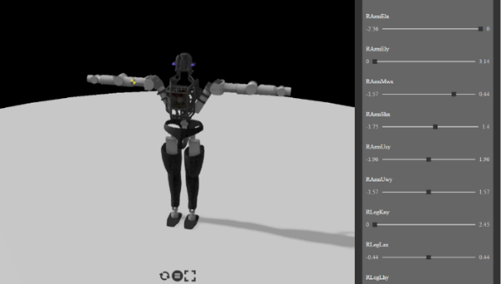
- Atlas Humanoid Robot from Boston Dynamics
In Webots, at each of the 28 joint, a Rotational Motor will allow this humanoid to freely move about the predefined 28 degrees of freedom. Having motors, allow the extraction of the motor’s rotational speed and allows some other kind of motor control. But no information about the rotational position $θ$ can be extracted without adding a Position Sensor or a Rotary Encoder at each rotational motor along with giving each sensor a reference name tag. One more additional step before creating the controller which will be in charge of passing the instructions to the robot and acquiring the data to be collected, the acceleration parameter at the motors of the robot is to be changed. If the acceleration parameter at the motor is kept ideal and the robot is subjected to a disturbance, when the response at all joints is monitored, little is the difference. In other words, the effect of the force can hardly be detected or recognized due to the rigidity of the joints of the robot. Lowering the rigidity of the joints and keeping the robot more malleable, yield to results with remarkable changes due to different types of disturbances.
- Data Collection Process
Some essential parameters for the initialization are the buffering time, which is taken to be 5 seconds to ensure the successive tests don’t interfere, the elapsed time for which a sample is going to be taken which is 7 seconds. Upon running a simulation, the resulting output is a set of 28 arrays of 70 elements each. Also the location at which the force is going to be applied on the robot needs to be determined along with the initial magnitude force, its incrimination and also the time for which it is going to be applied which was set to be equal to 2 seconds. The direction in which the force is applied is also known to be along the x-axis. At this stage the simulation starts by a buffer time of five seconds for the robot to settle in the environment then the force is applied for two seconds, and all 28 sensors start to acquire the data and fill it in the arrays for seven seconds starting with the force. As the simulation runs properly, the sensor readings can be save in a matrix which is essential for creating the dataset needed for the classification to determine the magnitude of the applied force and its location. The matrix of all 28 sensor readings is appended every time a new sample is to be added after taking reading from a simulation after incrementing the force applied by a predefined force incrimination constant. And the same process repeats until a predefined limit is reached. At this point the simulator quits the application. In Fig. 3, the process is explained in a flowchart and Fig. 4 shows an example of the resulting collected data on one joint only.
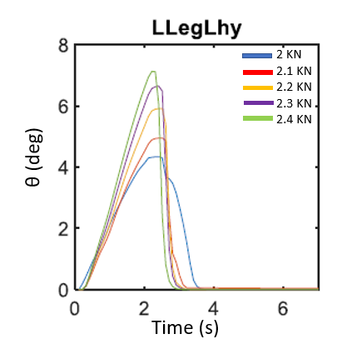
- Effect of a Force Applied on the Left Leg in Incrementing Intensities

Machine Learning Algorithm
For the machine learning algorithm, the work is going to be constrained to the selection of 6 locations (left and right arms, left and right legs, pelvis and torso) on which a force along x-axis can be applied on the center of gravity of the link, and instead of acquiring data from 28 sensors only 18 sensors located around the 6 selected locations on which a force can be applied will be considered. When the force is applied along the x-axis direction, some sensors are triggered more than others showing the effect of the force in the vibrations. Having a dataset formed of sensor readings is an intermediary step. For the dataset to be ready to be used in a machine learning algorithm which will serve for the classification of the data and the detection of the force magnitude and location, the dataset must not contain samples of sets of sensor readings or signals. Each signal is to be processed and three features of this signal are extracted and used as measurements that can help in providing a unique identity of the curve. Therefore, as shown in Fig. 4, 18 sensor readings will be processed and 3 features; the mean, standard deviation and the mean frequency of each signal made clear in Fig. 5 will be extracted from each were the end result in an array of 54 features instead of having an array of 18 arrays.
- The Variation of Angular Position (degrees) in time (s) fot the 18 Joints in One Data Sample
- 54 Features Extracted from 18 Sensor Readings

Results and Conclusion
The total number of samples collected in the dataset in 1300 which is a number of samples enough to undergo a good classification procedure and expecting reliable results. Both classification problems for the force magnitude and the location are to be run alone. In this research, the MATLAB classification toolbox was used. So, the dataset is loaded as a matrix of numbers. Next in the classification toolbox the dataset is selected along with the features and indicating the response which can be the force magnitude range or the location. The settings are also calibrated indicating the desired percentage to be taken for the testing and the training data. In the training phase, 70% of the dataset is taken along with the responses. Whereas in the testing phase 30% of the data is taken and classified based on the training that the algorithm has learned, and the actual response is compared with the desired or expected response of the classification. Finally, the error and the accuracy are calculated to evaluate the performance of the algorithm and the results are all displayed in confusion matrices.

Results
As the data samples are now distributed and scattered, the best classification algorithm can be deduced. But in this case, due to the high number of dimensions, 21 algorithms are used and the algorithm with the highest accuracy is the one to be considered. Taking the algorithm with the highest accuracy into consideration is adopting the algorithm with the lowest error. The best model to classify the data collected is the Ensemble Bagged Trees model which performed with a 97.3% accuracy to classify the force magnitude range and a 98.8% accuracy to classify the force location. We can deduce that this algorithm converges to solutions with 2.7% error for the force magnitude classification and 2.2% for the force location classification. The selected algorithm is a powerful one since such system is also known as a multiple classifier system that takes more than one model into consideration and then brings up the result of the majority of the models [10]. The results of the Ensemble Bagged Trees algorithm are shown in the figures below. The confusion matrices in Fig. 6 and Fig. 7, declare the number of times the model made a good guess or a false guess for each response.
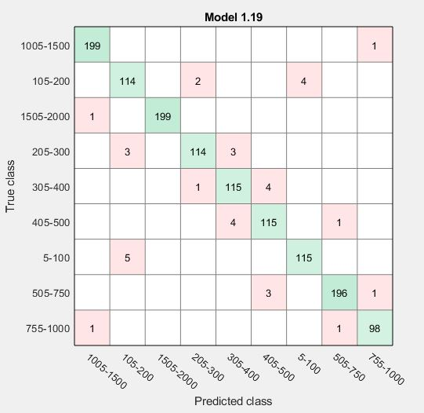
- Farce Magnitude Rabge Classifiction Confusion Matrix
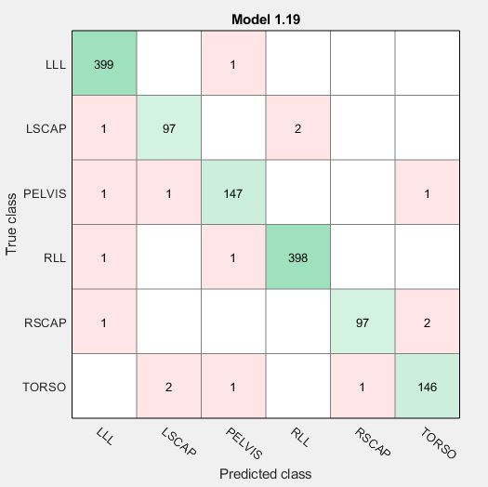
- Farce Location Classifiction Confusion Matrix

Conclusion and Future Work
Humanoid robots are designed in very complicated systems aiming to mimic and imitate human behaviors and motion. Whereas humanoid robots are still missing a lot. One of the main capabilities of humans that humanoid robots still do not have the privilege to partake is the ability to identify and locate an external force or disturbance that is the main reason behind driving a humanoid robot out of its stability region. Giving a humanoid robot this ability will enhance its stability control and allow it to better perceive events from its surroundings and make better decisions accordingly. Whenever the topic of perception is brought up, the first thing that come to mind is the setup of sensors. In this research the use of an excessive number of sensors was minimized unlike other researches that tried to tackle the same problem and without having to solve the dynamic model equations each and every time data is collected. Instead, the machine learning algorithm takes into consideration all 54 features from a dataset of 1300 samples that was generated by the Webots controller. The classification problem can either classify the force magnitude range or the force location. Therefore, in each classification problem there is one response but for the force magnitude rage there are 9 possible classes and for the force location there are 6 possible classes. The classification learner indicated that the Ensemble Bagged Trees algorithm classifies best classifies the data with a 97.3% accuracy for the force magnitude range classification problem and 98.8% accuracy for the force location classification problem.

Acknowledgment
we would like to express my sincere gratitude to the American University of Science and Technology. It was a great privilege and honor to conduct this research with guidance provided. we extend my sincere thanks to the Dean, Chair, and all members of the Faculty of Engineering for their endless support.

References

- Choudhury, Avishek, et al. "Humanoid Robot-Application and Influence." arXiv preprint arXiv:1812.06090 (2018).
- Emi Kolawole (July 12, 2013). "What if this ATLAS shrugged? DARPA unveils new humanoid robot". The Washington Post. Retrieved July 14, 2013.
- Dhande, Ashwin. (2017). Multitasking Humanoid for Surveillance & Monitoring.
- M. Benallegue et al., "Model-Based External Force/Moment Estimation for Humanoid Robots with no Torque Measurement," 2018 IEEE International Conference on Robotics and Automation (ICRA), 2018, pp. 3122-3129, doi: 10.1109/ICRA.2018.8460809.
- A. Mifsud, M. Benallegue and F. Lamiraux, "Estimation of contact forces and floating base kinematics of a humanoid robot using only Inertial Measurement Units," 2015 IEEE/RSJ International Conference on Intelligent Robots and Systems (IROS), 2015, pp. 3374-3379, doi: 10.1109/IROS.2015.7353847.
- G. Zuo, Y. Qiu, Y. Liu and X. Huang, "Sensorless External Force Detection Method for Humanoid Robot Arm based on BP Neural Network," 2019 IEEE 9th Annual International Conference on CYBER Technology in Automation, Control, and Intelligent Systems (CYBER), 2019, pp. 265-270, doi: 10.1109/CYBER46603.2019.9066734.
- M. Tahoun, A. Tayba, S. Alfayad, A. Wahdan and L. Chassagne, "Force Localized Interaction Sensing System for HYDROïD Humanoid Robot," in IEEE Sensors Journal, vol. 20, no. 8, pp. 4112-4119, 15 April15, 2020, doi: 10.1109/JSEN.2019.2962281.
- Ramos, Oscar. (2014). Generation of the whole-body motion for humanoid robots with the complete dynamics.
- Meghdari, Ali & Sohrabpour, s & Nezamoddini, Seyed & Izadi, Ehsan & Tamaddoni, Seyed Hossein & Basafa, Ehsan. (2005). Dynamics Modeling of a Humanoid Robot. 10.1115/DETC2005-84446.
- Robi Polikar (2009) Ensemble learning. Scholarpedia, 4(1):2776.

Authors’ background
Name | Prefix | Research Field | Email | Personal website
Samia Choueiri | Master Student | Mechatronics and Robotics | Samia.choueiri@hotmail.com | -
Hassan Diab | Assistant Professor | Mechatronics and Robotics | hdiab@aust.edu.lb | -
Michel Owayjan | Senior Lecture | Mechatronics and Robotics | mowayjan@aust.edu.lb | -
Roger Achkar | Associate Professor | Neural Networks | rachkar@aust.edu.lb | -

